Peter the Great St. Petersburg Polytechnic University

_______________________________________

[Institute of Computer Science and Technology](http://english.spbstu.ru/structure/institut_computernikh_nauk_i_tekhnologiy/)

Department of Computer Systems & Software Engineering

Lecture

*Creating a System Design with Qsys*

student:

Ivanov Il’ya

group: 3530901/70203

lecturer:

Antonov A.P.

Saint-Petersburg

2020

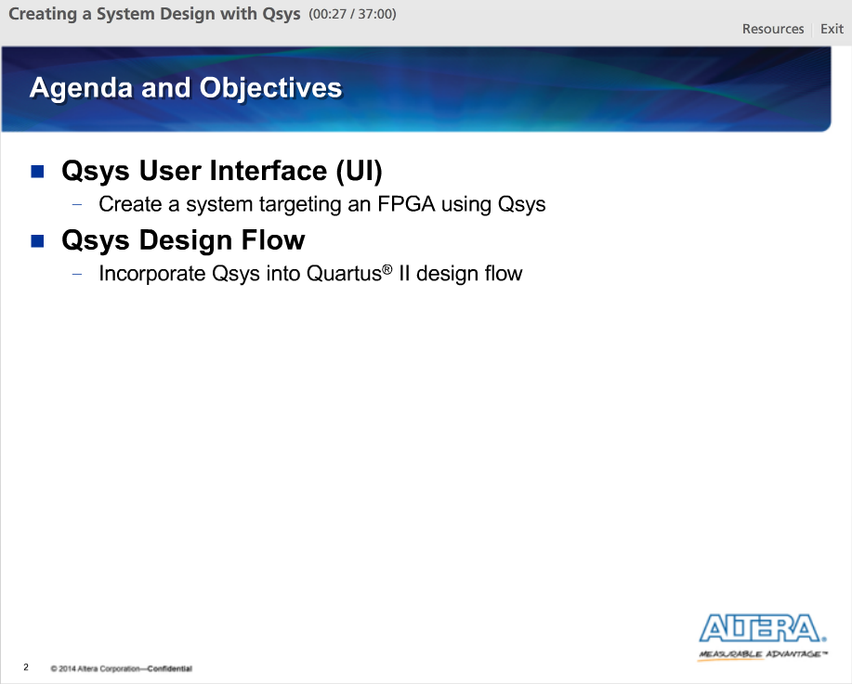

In this lecture, we will cover the Qsys user interface and design flow. By the end of this lecture, we will:

1) Have a better understanding of Qsys and how to use it to build a FPGA-based system.

2) Understand how Qsys fits into the Quartus II software design flow

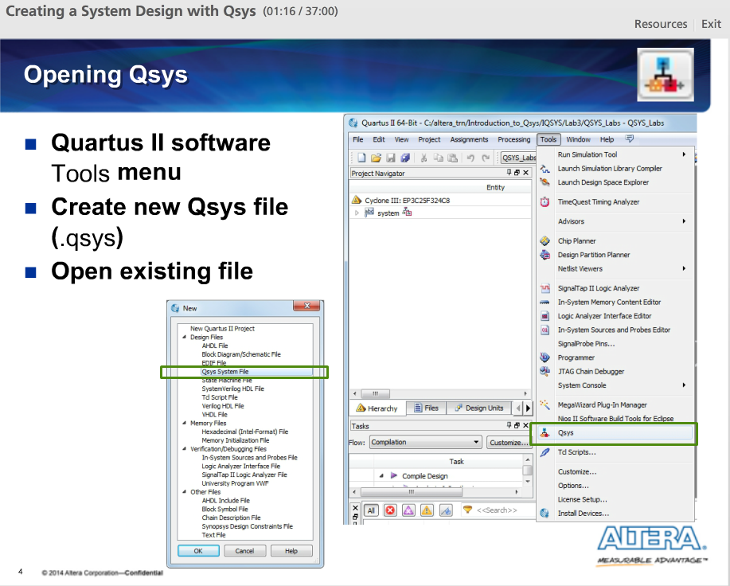

We can launch Qsys by selecting it from the Quartus II Tools Menu. There is a toolbar button we can use as a shortcut.

We can also launch Qsys by going to the File menu and selecting New. From the New dialog box, select Qsys System File as the design file type and the Qsys UI will open.

If we have an existing Qsys design we want to modify, we can go the File menu, select Open and choose the .QSYS file for our system. Again, the Qsys UI will open.

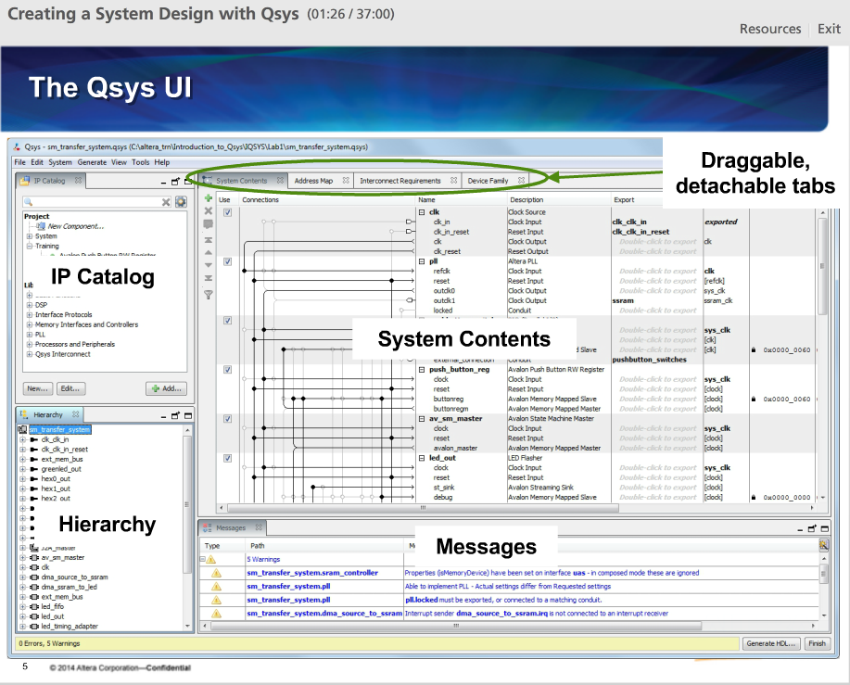

An example of the Qsys UI with the main view and tabs visible.

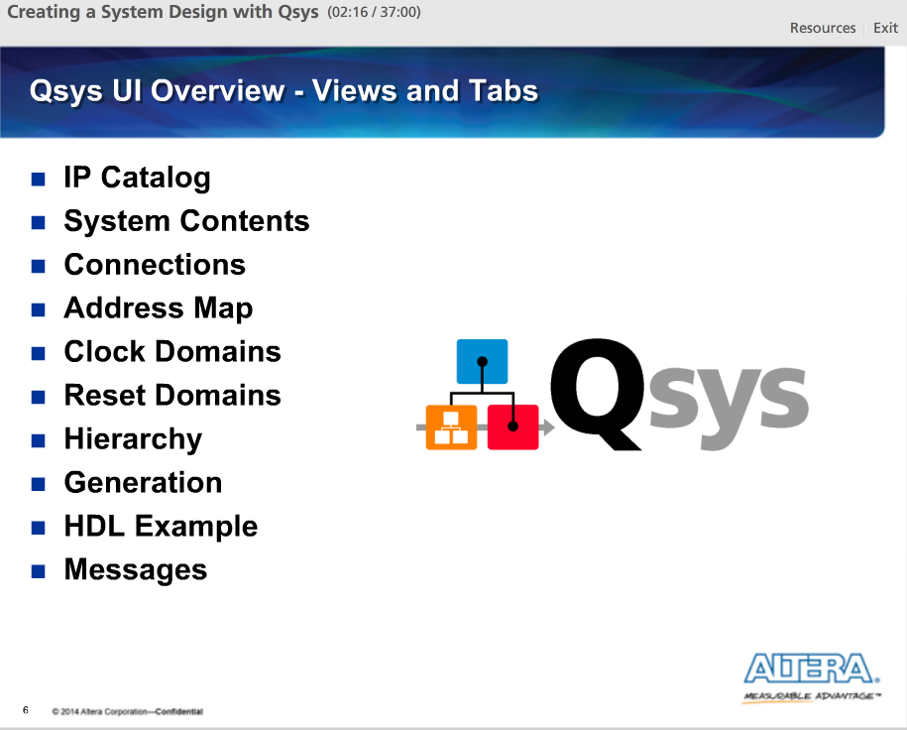

The Qsys UI is made up of a series of tabs we use to both build our system and analyze the results. All the tabs can be enabled and disabled as needed based on the information we need to view.

This slide shows a list of most, but not all, of the tabs found in the Qsys UI. Listed here are all of the tabs that would be used when building a basic Qsys system.

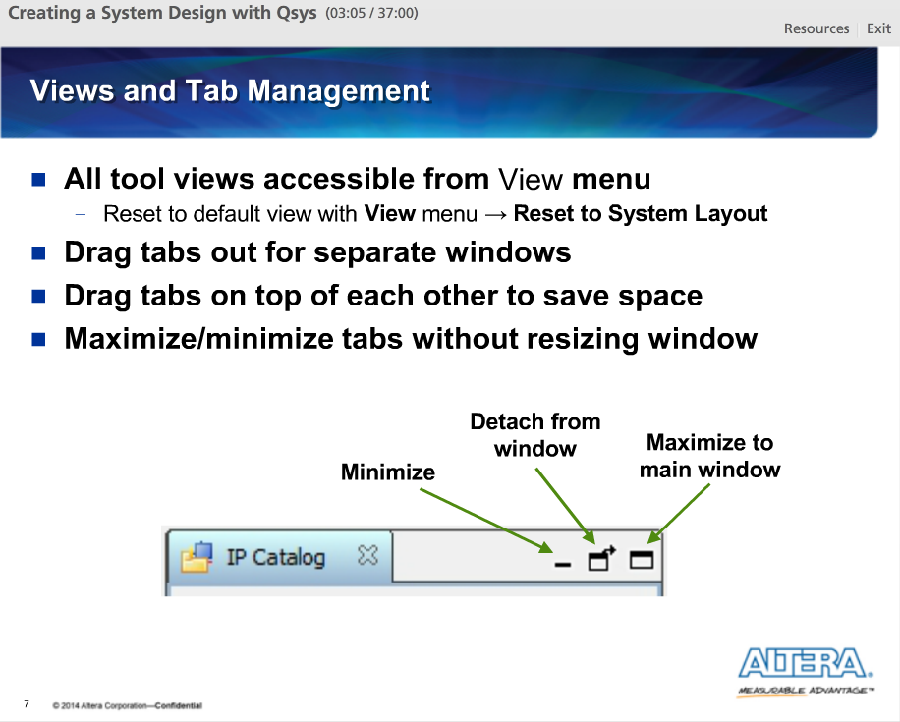

All the different views and tabs can be enabled or disabled for viewing from the View menu. Click once on the view tab or tab name to enable or disable and a second time to restore the previous state.

Click and drag the tabs to reposition them. We can also detach, or separate, the tabs from the main Qsys UI.

Each tab can also be minimized or maximized by clicking on the icons in the upper right portion of that display tab.

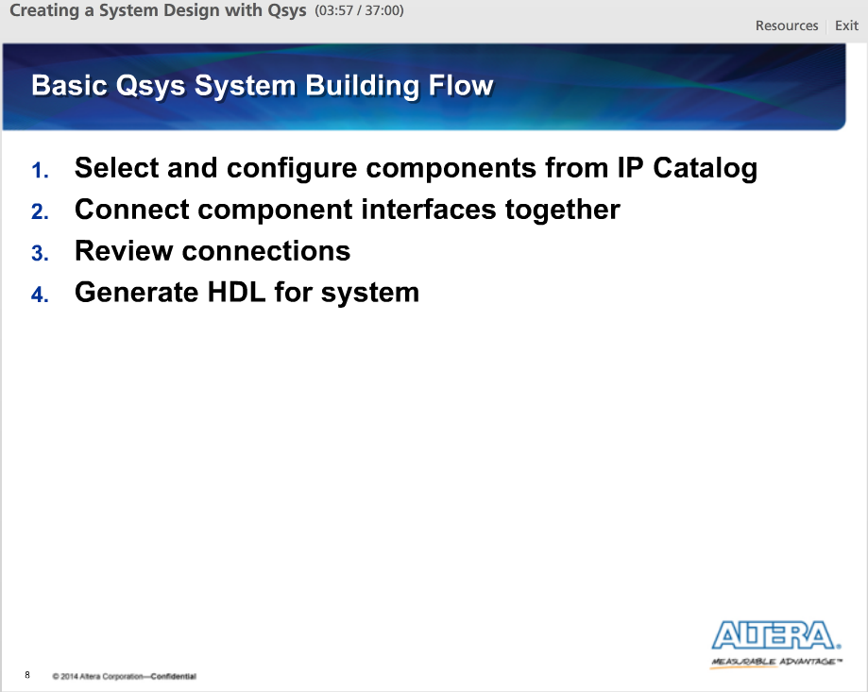

Four steps for building a basic system in Qsys.

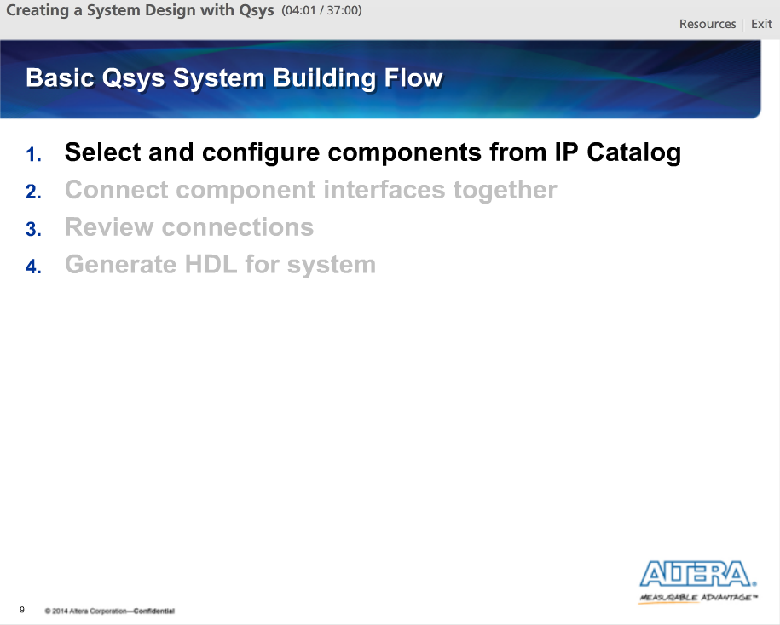

First, we select and configure components from the IP Catalog.

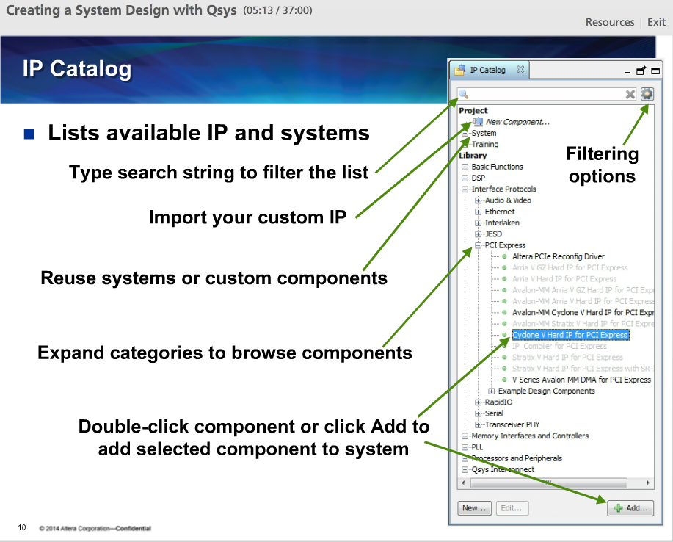

The IP catalog lists all of the IP that are available and can be added to our current Qsys system.

The IP Catalog is organized by categories to make it easier to find the IP we need. A very helpful feature is the search field. We can use it to filter the IP Catalog by name.

To add a component to our system, we can double-click on the component name in the IP Catalog or highlight the component and click on the Add button.

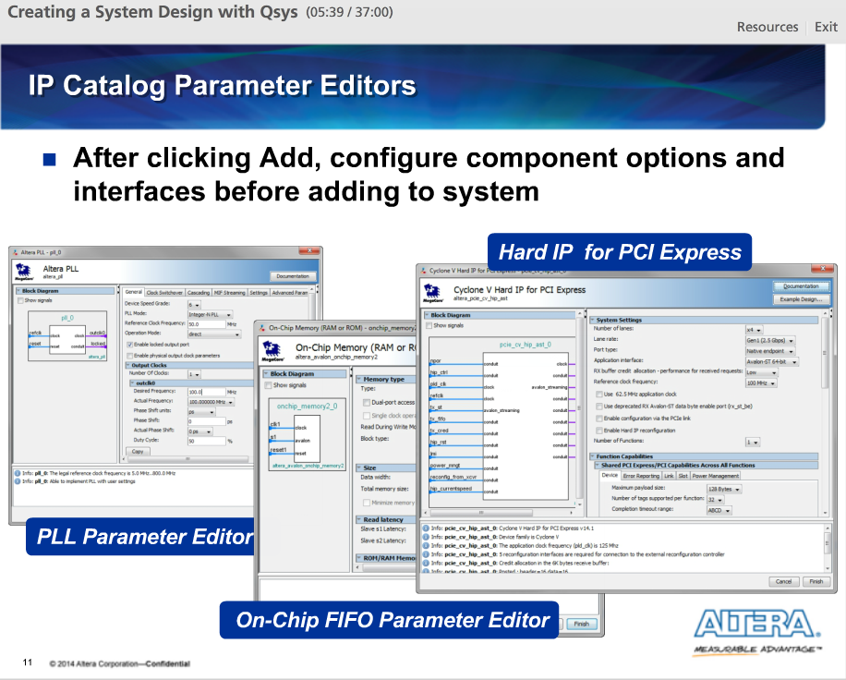

After clicking Add, a component parameter editor window opens which allows us to customize the component for our system specification. Each copy of a component added to our system can be configured separately.

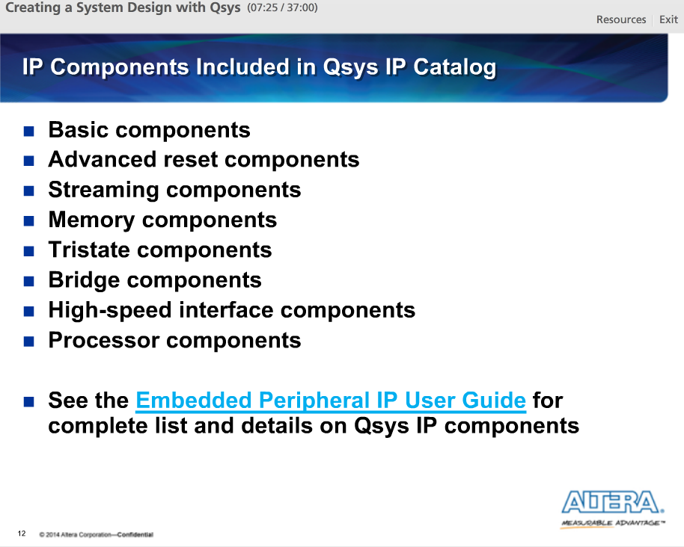

Some component types that we can add to our system:

1) Basic components include a clock source component and a reset source component

2) Advanced reset components include a reset controller and reset sequencer

3) Streaming components are used to connect and manipulate the data flows between Avalon-ST interfaces

4) Memory components are on-chip RAM, ROM and FIFO components. They are also include controllers that connect to off-chip memory chips like flash, SRAM and SDRAM chips as well as direct memory access (DMA) components, both regular and scatter-gather

5) Tristate components allow us to connect to external devices that use bi-directional data busses and to share a single set of FPGA pins amongst multiple external devices

6) Bridge components allow us a measure of control of our custom-generated interconnect by inserting pipeline stages, asynchronous clock crossing logic and logic to bridge between 32-bit & 64-bit systems. We can also bridge to other interface types such as JTAG and SPI.

7) High-speed interface components implement the protocol layers needed for high-speed specifications like Ethernet, PCI Express and Interlaken.

8) Processor components allow us to added processor solutions like the Altera Nios II and the ARM dual-core Cortex A-9 processor found in select FPGA variants

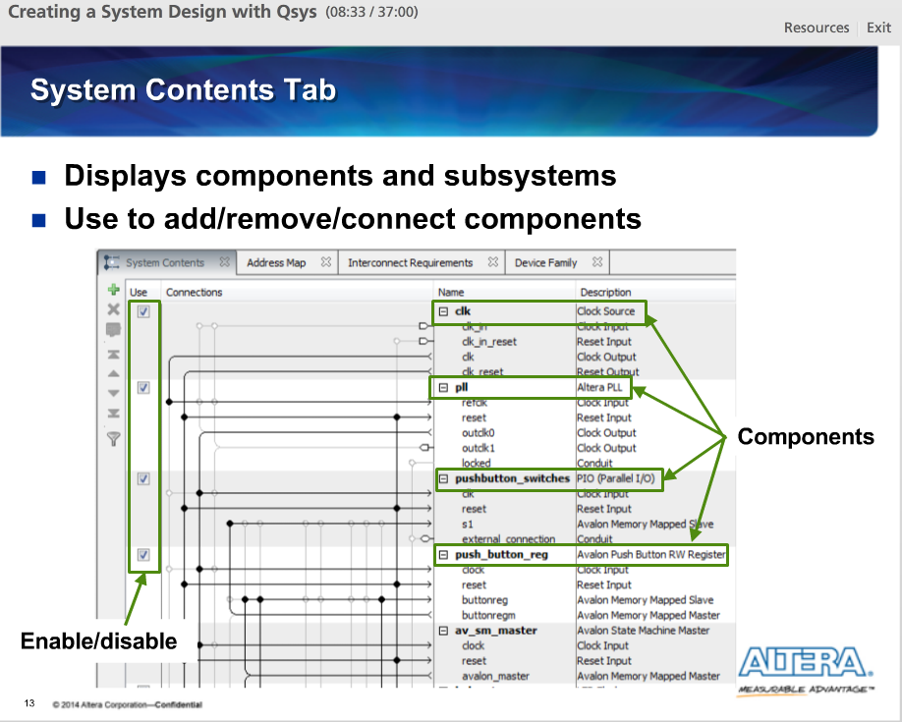

The System Contents tab displays all of the components and subsystems that have been added to the current system. We can use this window to easily manipulate a component’s relationship to the rest of the system including its connections to other components, it’s connections to top-level I/O (external to system) and its location in address space (memory mapped slave ports).

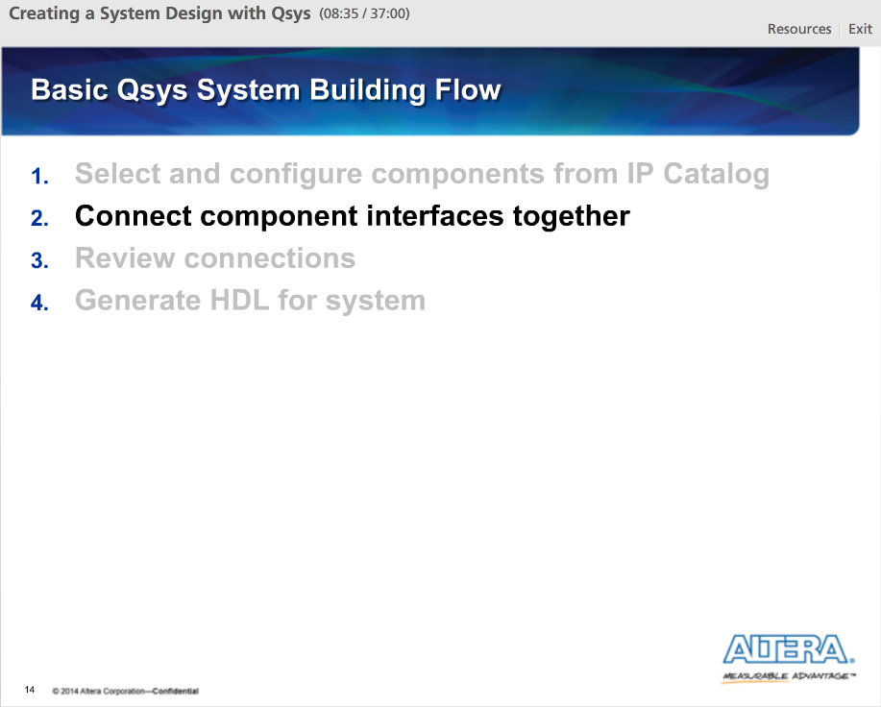

For step two, we want to connect the components in our system together.

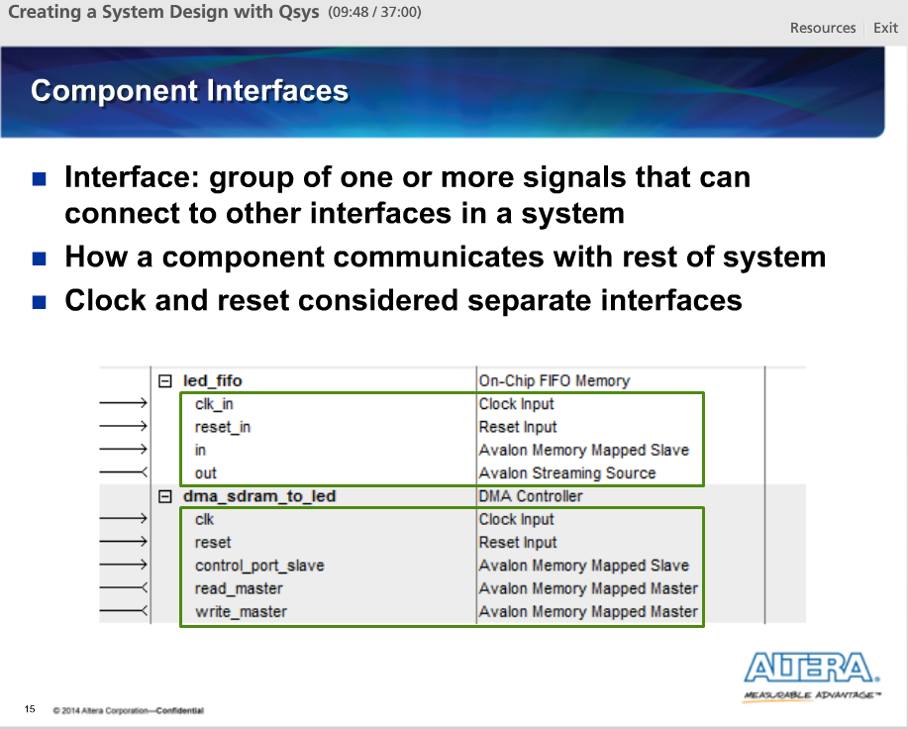

When we add a component to our system, the System Contents tab displays all of the interfaces for the component. Each interface is a separate group of signals that a component uses to communicate with other components in the system. Most, but not all, component interfaces need to be connected.

Note clocks and resets are considered separate interfaces and should be connected individually.

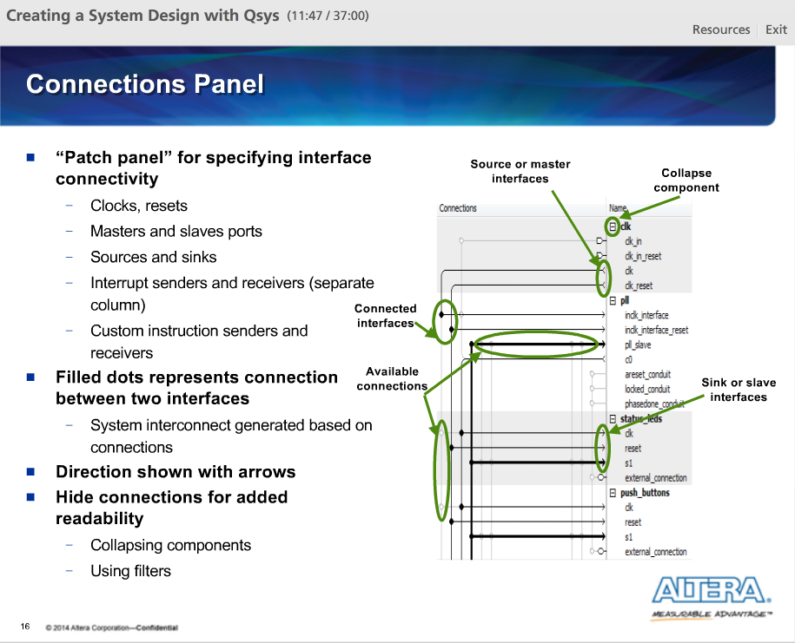

The Qsys Connections Panel of the System Contents tab is the primary way to connect components together and review the connections we made. Based on the connections in the Connections panel, Qsys generates a custom-built interconnect structure.

Looking at the Connections Panel, an arrow pointing away from the interface indicates that it is a master, clock output, reset output, source or sender interface. An arrow pointing into the interface indicates that it is a slave port, clock input, reset input, sink or receiver interface.

The Connections Panel can become very busy and hard to read easily. We can make the Connections Panel more readable by hiding connections that we currently don’t need to see.

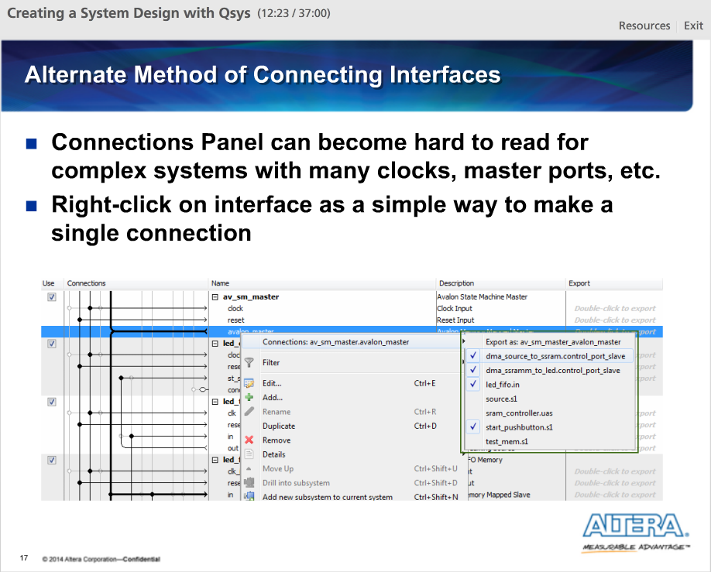

With vary complex systems, the Connections Panel can become difficult to decipher and it can be easy to make incorrect connections. A simple way to make a single connection between two interfaces is to right-click on one of the interfaces we want to connect. Within the Connections sub-menu, we will find a list of all of the valid connections for the interface we selected.

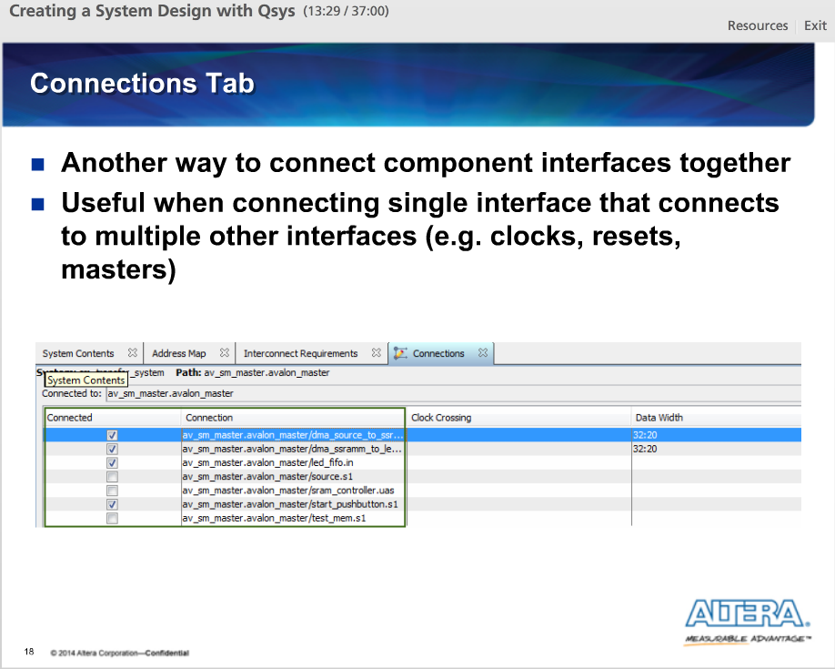

Another way to connect component interfaces together is Connections Tab. Once opened, we will see a list of all of the valid connections for the interface we selected in the System Contents window.

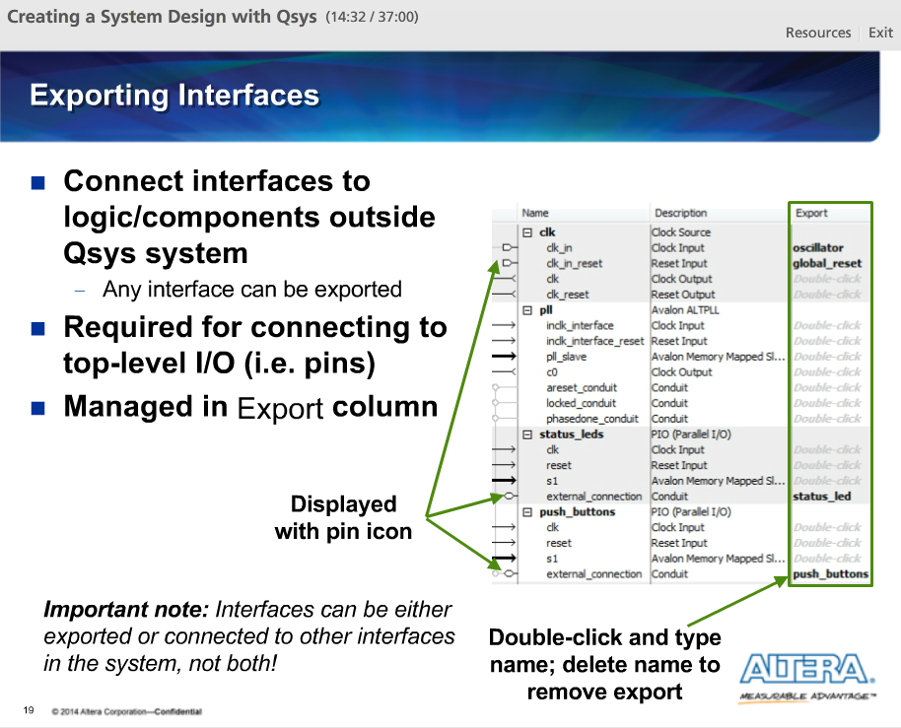

In Qsys, any component interface shown in the System Contents tab can be exported. By exporting, the signals that make up that interface are brought out to the top-level of our Qsys system to be connected externally. By externally, we mean outside the Qsys system. These signals can connect directly to FPGA I/O pins or to other logic within the FPGA but not the Qsys system.

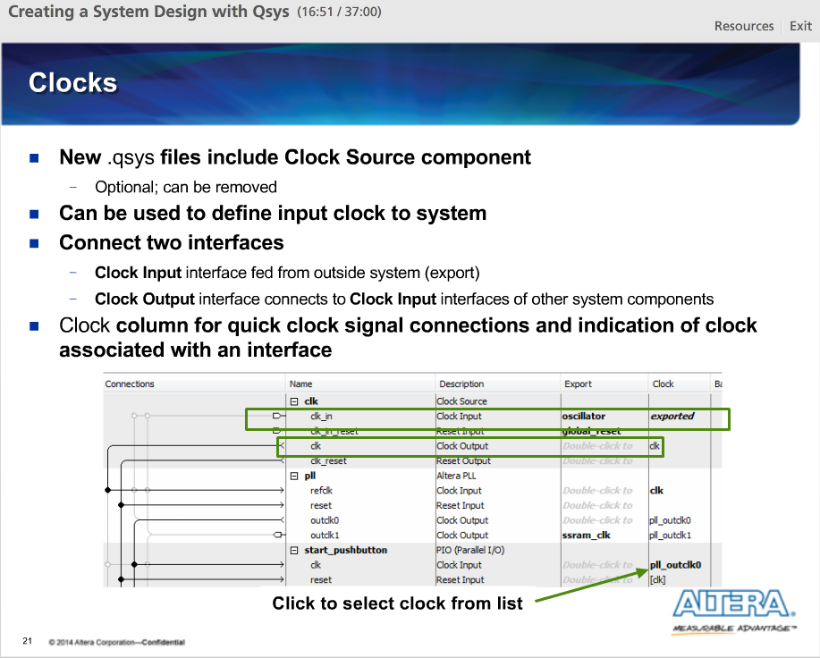

The Clock Source component is used to clock the other components in our Qsys system if they use a shared clock. We can use it to define an external clock that enters our system and drives other components. By default, this component will be present in all new .QSYS files. Right-click on the component and select edit to open its parameter editor and specify the clock frequency. Each Clock Source component has a Clock Input interface and a Clock Output interface.

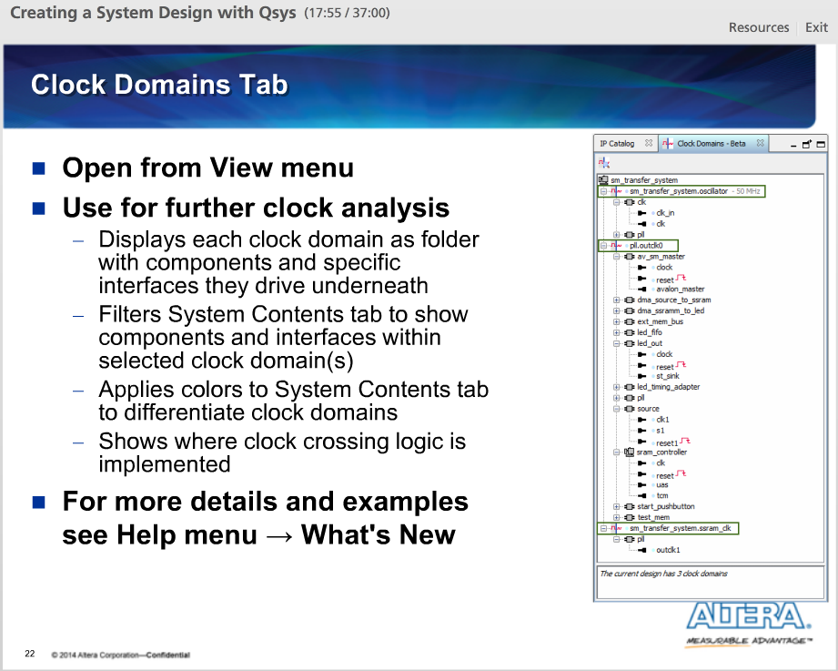

For more information regarding your system clocking, open the Clock Domains tab from the View menu. This tab displays clock domains as hierarchy regions with each component and that component’s interfaces in that clock region displayed underneath.

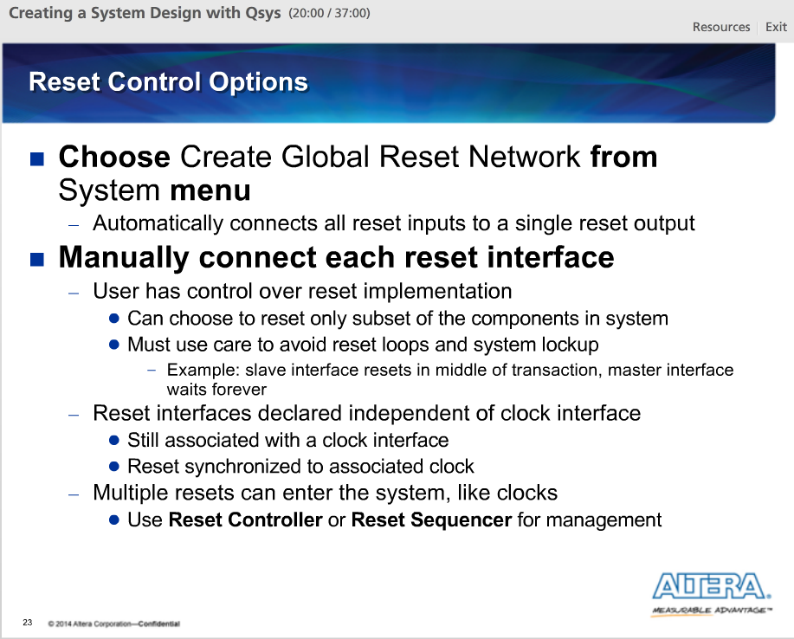

Reset interfaces are separate from clock interfaces, though they are still associated to a particular clock domain. External resets enter the Qsys system just like clocks, using the Clock Source component. When configuring the Clock Source component, we can explicitly control the synchronization of the reset with respect to the clock signal of that component.

Resets may also be generated by other components in our system. They can provide their reset control to the system by employing a reset output interface.

Qsys allows designers to use one of two methods for the connection of resets.

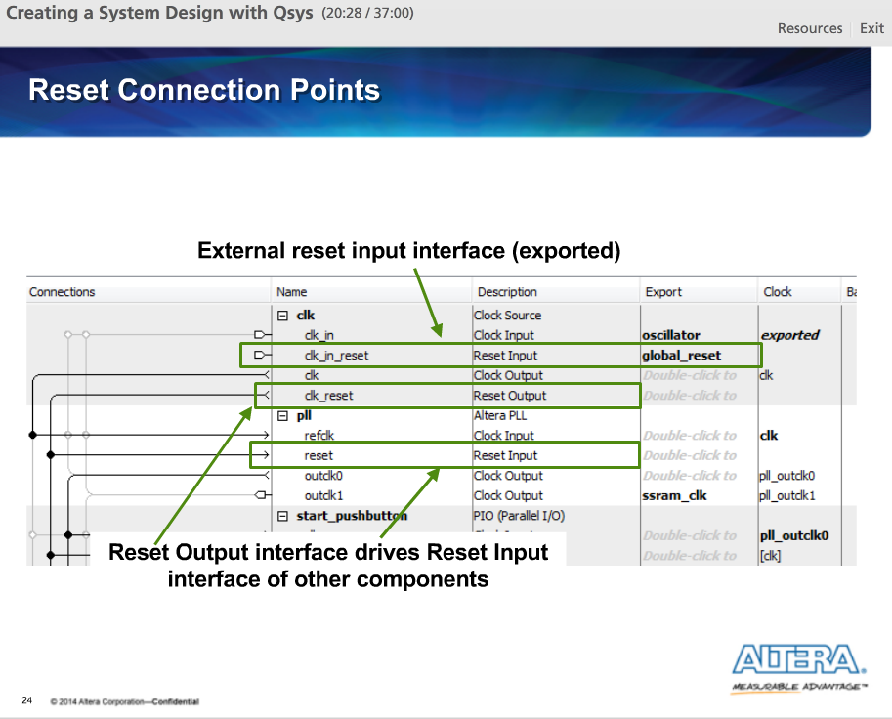

This example shows resets being hooked up manually. Here the reset input interface of the Clock Source component, a component named clk, is exported to a port named global_reset. Then the reset output interface, clk_in_reset, is connected to reset input interfaces in the rest of the system, in this case the reset input interface of the pll.

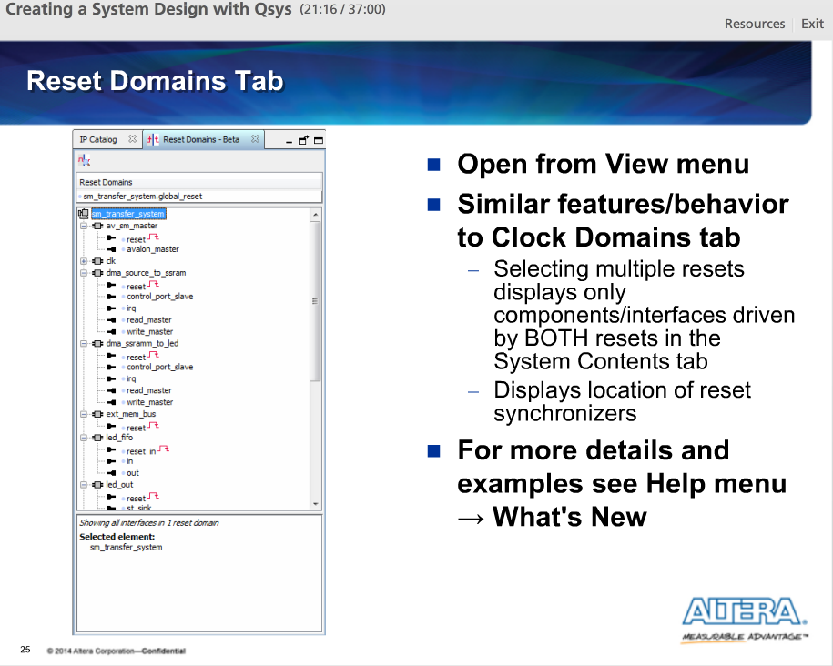

Similar to the Clock Domains tab, there is also a Reset Domains tab available from the View menu. Using the Reset Domains tab, we can see which components and interfaces are in which reset domains.

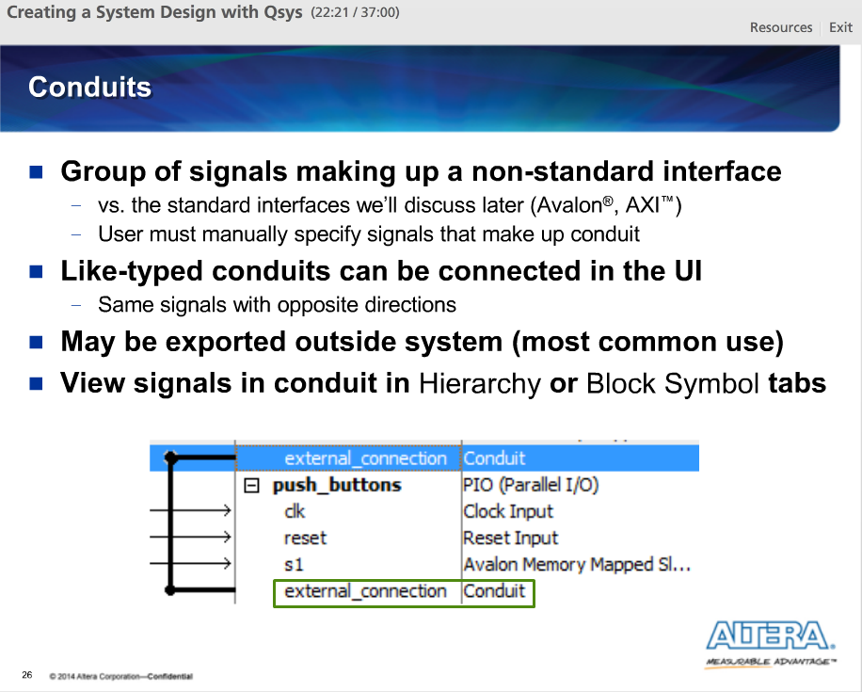

Conduits in Qsys represent any non-standard interface types or signal groups. They can contain any arbitrary signal or collection of signals. They appear right along standard interfaces for a component in the System Contents tab and can be connected to other conduits with the same signals or exported out of the system to be connected externally (e.g. I/O signals that connects to LEDs, high-speed transceiver I/O).

For IP in the Qsys library, conduits and their signals are already defined. If we create any custom components, then we must specify what signals make up the conduit.

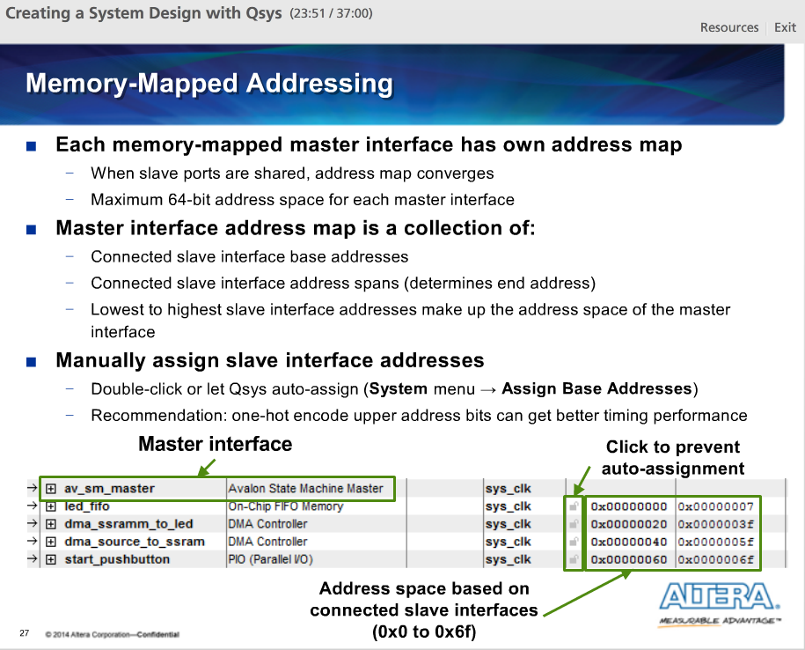

On the System Contents tab, we can define the addressing for the memory mapped, or control plane, portion of our system. Each memory mapped master interface has its own unique address map it uses to access the slaves to which it is connected.

In multiple master ports connect to the same slave port then the master ports addresses maps converge as the slave ports will, by default, be assigned the same address for each master port.

Qsys automatically populates the base and ending address of each slave interface. To change the assigned address for a particular slave interface, double-click on its base address and type in a new address.

The maximum address width supported by Qsys for any master interface is 64-bits.

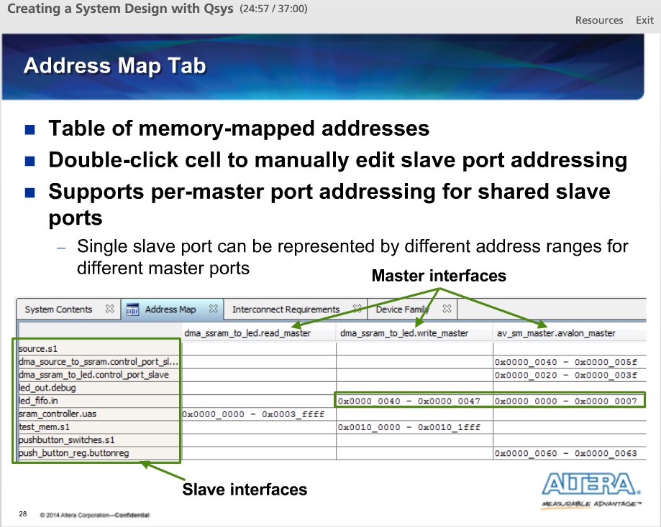

The Address Map tab contains a table of all memory mapped device addresses, making it a little easier to learn the address mappings and address spans in our system, versus viewing the same information on the System Contents tab.

Here each memory mapped master port is indicated by a column and each memory mapped slave port is indicated by a row. If the master and slave ports are connected then the cell representing their intersection is filled with the slaves port address as that master port sees it.

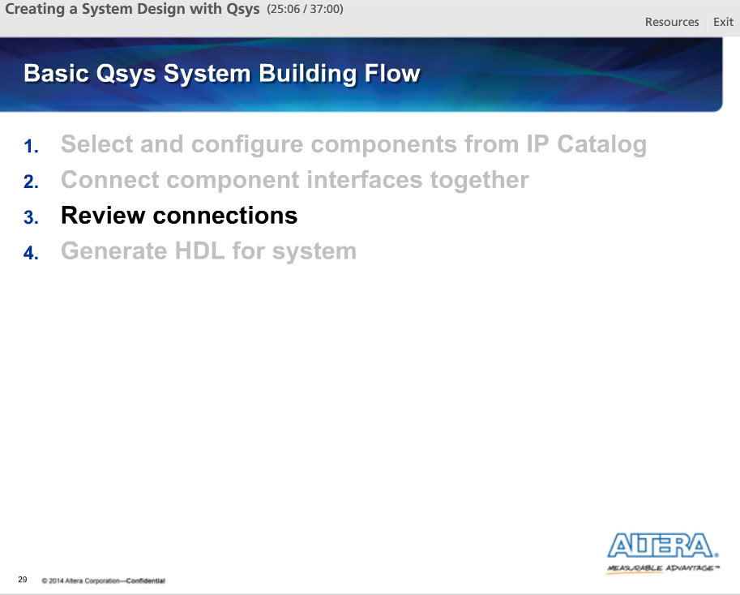

Step three of the basic Qsys system flow is to review the connections we made between components in our system.

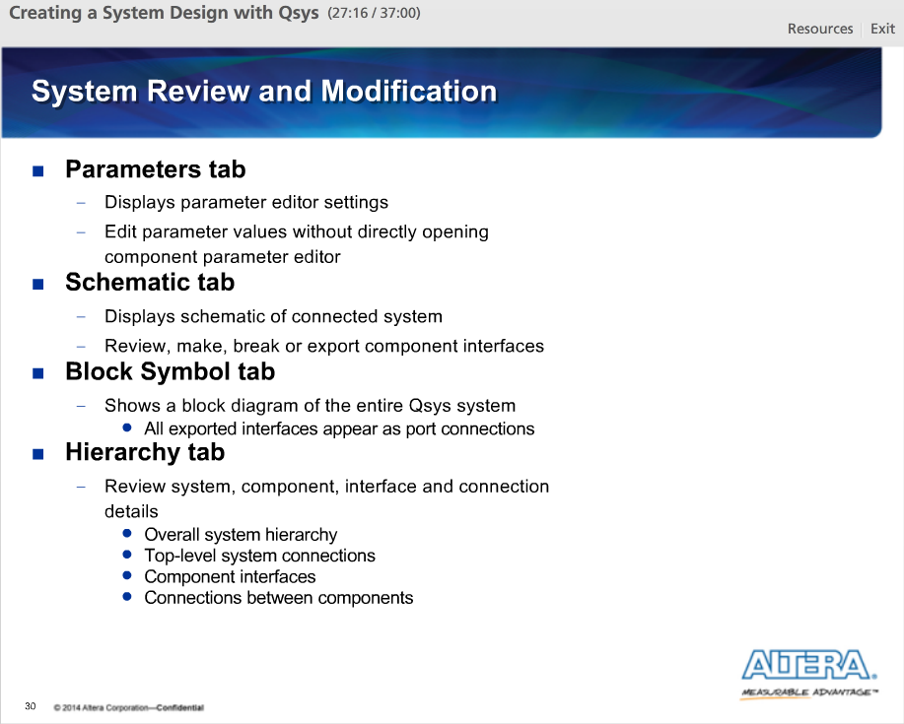

Now that our system is built, it is time to review our system components and their connections and make any necessary modifications. At any time during building of our Qsys system, we can use the various Qsys tabs we have seen so far, like the System Contents and Clock/Reset Domains tabs, to do exactly this. However, there are additional tabs that can be helpful in this process. We can access all these tabs from View Menu.

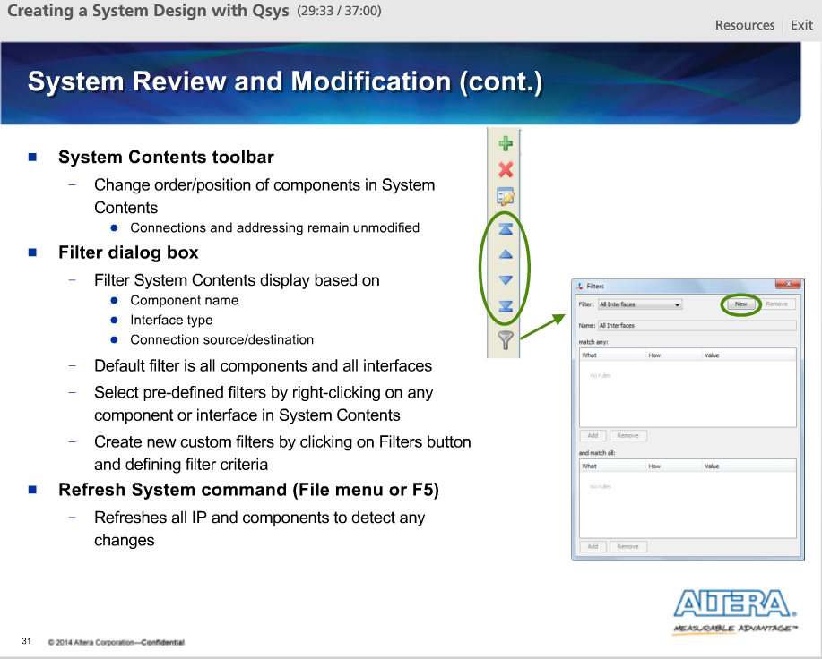

For system editing, the System Contents tab provides a tool bar that allows a designer to change the component ordering.

For more filter control, we can open the Filter dialog box from the System Contents toolbar. With the Filter dialog box, we can even filter based on component name. By clicking on the New button, we can also create custom filters and store them for future use.

Sometimes we want to force Qsys to refresh, or rebuild, our system using all of the current settings stored in the .QSYS file. We can do this by selecting Refresh System from the File menu or by pressing the F5 key.

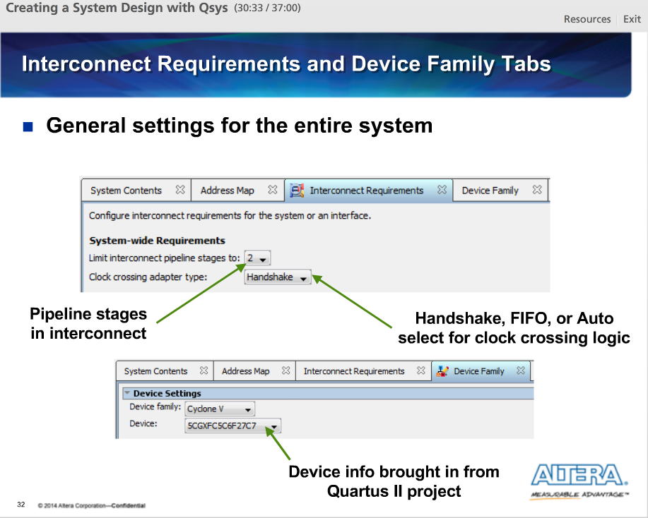

With the system built and reviewed, we are ready to generate the system with its custom interconnect.

On the Interconnect Requirements tab, we can choose options that affect the custom implementation of our Qsys interconnect. We can specify the maximum number of pipeline stages. This lets our tradeoff between system performance and the number cycles of latency to complete memory mapped transactions. We can also select how we want any automatically generated clock domain crossing logic to be implemented, as handshake logic, as FIFOs or Auto (i.e. to let Qsys choose).

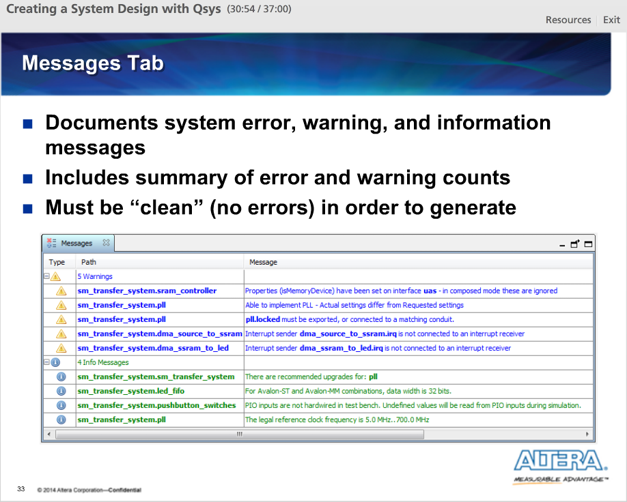

At the bottom of the Qsys UI is the Message tab. This documents all system informational, warning and error messages, organized by message type. At the very bottom of the tab is the total number of each message type.

In order to generate a system, all error messages must be eliminated.

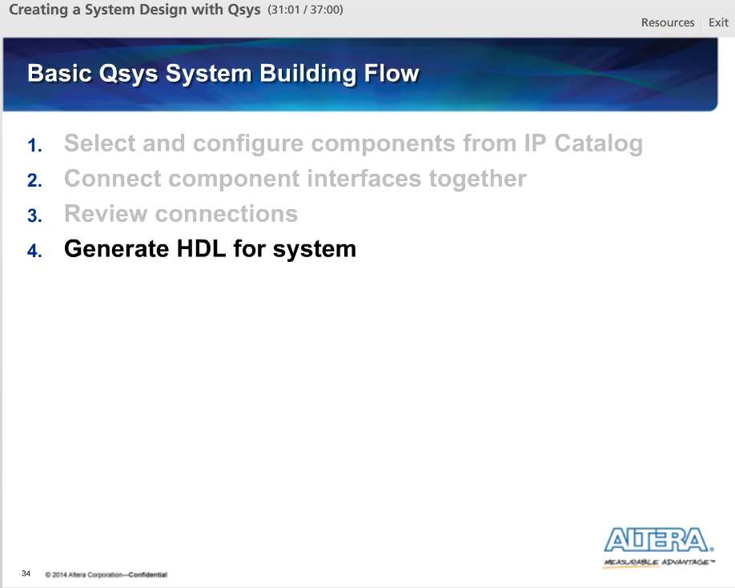

For step four of the basic Qsys system building flow, we will generate HDL for our system.

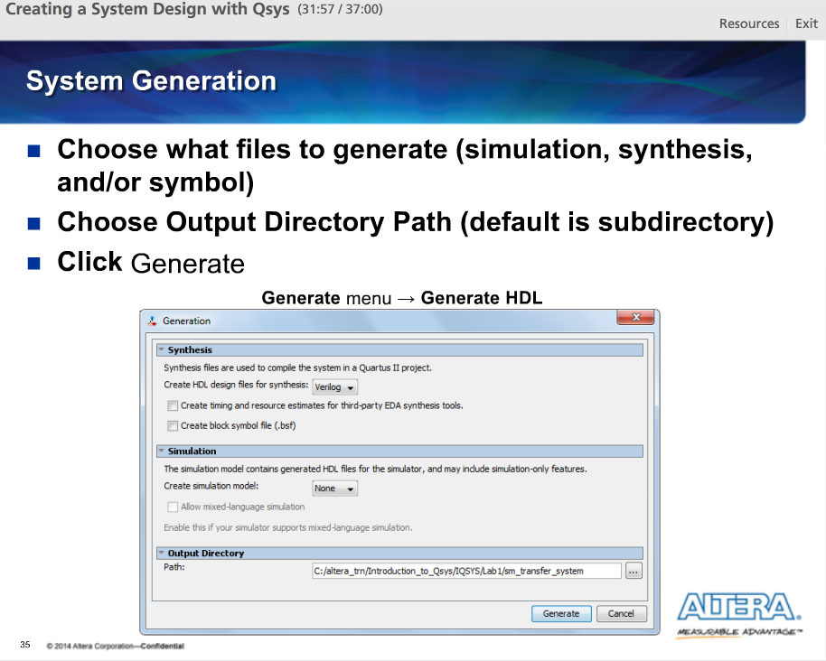

At the bottom of the Qsys UI, click on the Generate HDL button to open the Generation window. You can also open it from the Qsys Generate menu. In this window, you can select what files you want Qsys to generate based on the planned method for simulation or synthesis. For synthesis or simulation, a top-level Verilog or VHDL file can be produced. Click on the Generate button and the source files representing your Qsys system will be created.

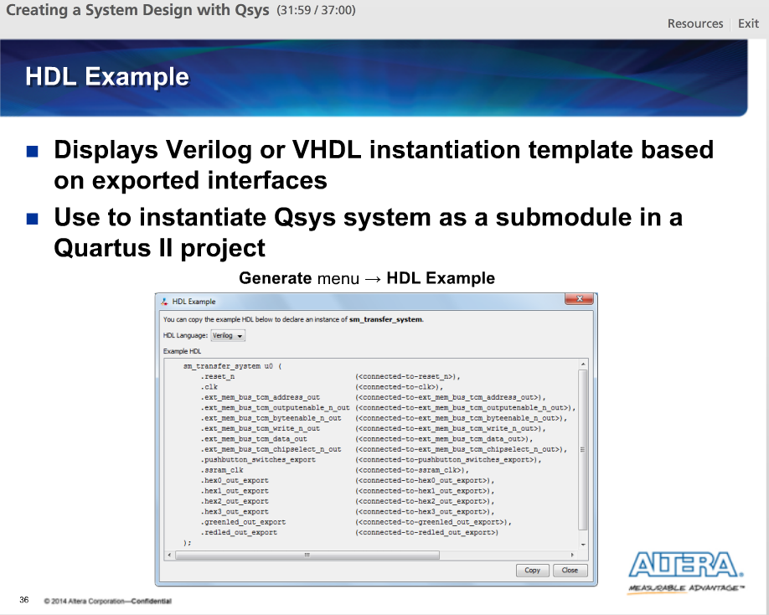

If your plan is to instantiate a Qsys system as a sub-module in another design file, then Qsys provides an instantiation template for this located on the HDL Example tab. Choose between a VHDL and Verilog template.

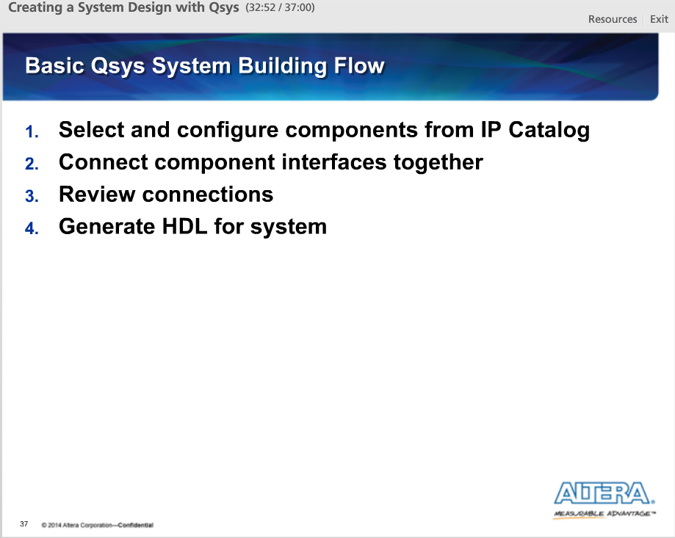

That concludes our look at the system building flow using the Qsys UI.

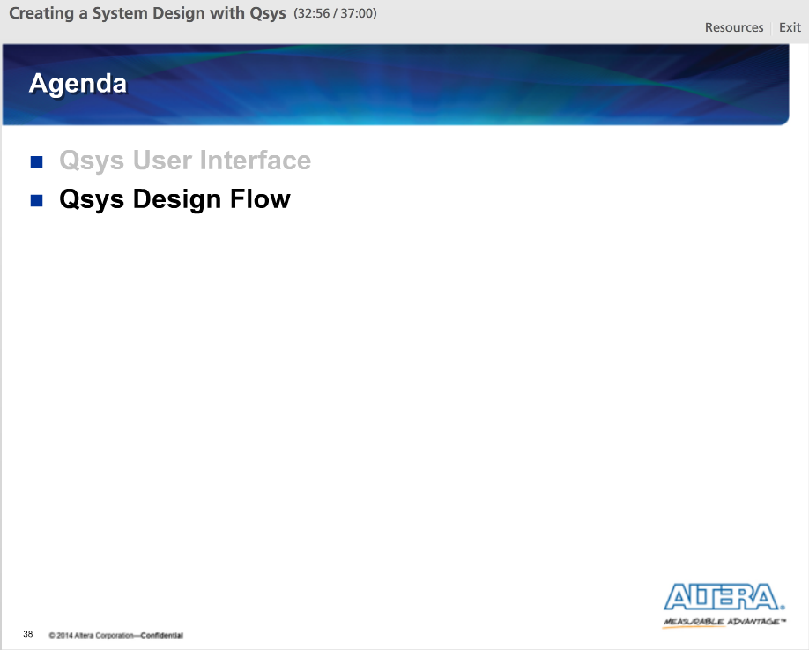

With our system generated, we can now incorporate our Qsys system into the Quartus II design flow.

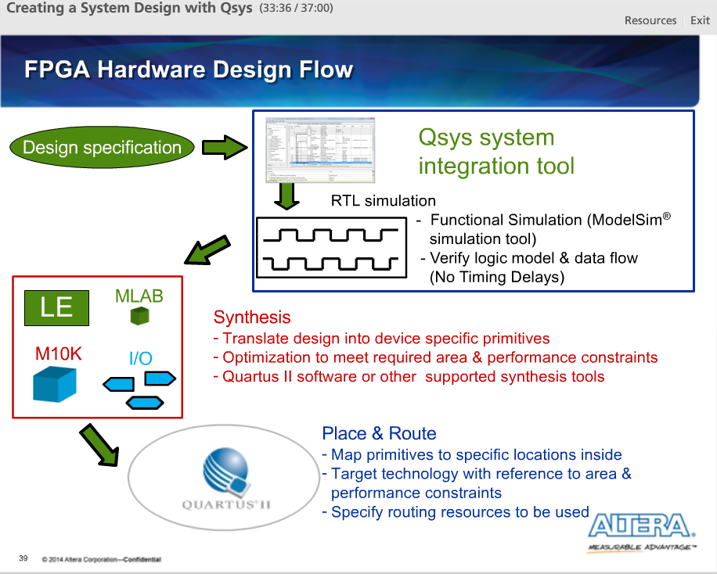

A typical FPGA design starts with coding the RTL according to our required specifications. Qsys is a front-end tool to the FPGA design flow in that it is used to build a system. It generates HDL so that we can continue in the FPGA hardware design flow. After system generation, we can take the Qsys simulation output files to perform simulation in a tool like the ModelSim tool. We can then run synthesis on the Qsys output synthesis HDL files to continue in the hardware flow.

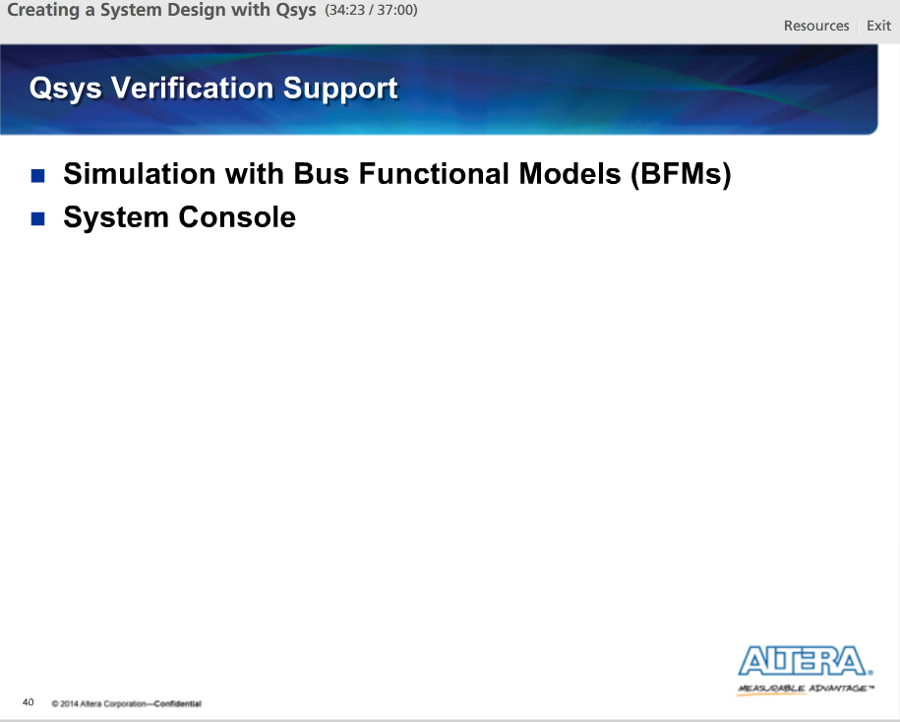

To aid in verification, Qsys has access to additional features such as bus functional models, or BFMs, and the System Console.

BFMs allow us to test our components standard interfaces, such as Avalon-MM, Avalon-ST and AXI interfaces, in a simulation environment.

The System Console allows us to do in-system testing of a Qsys system via the JTAG interface of the FPGA.

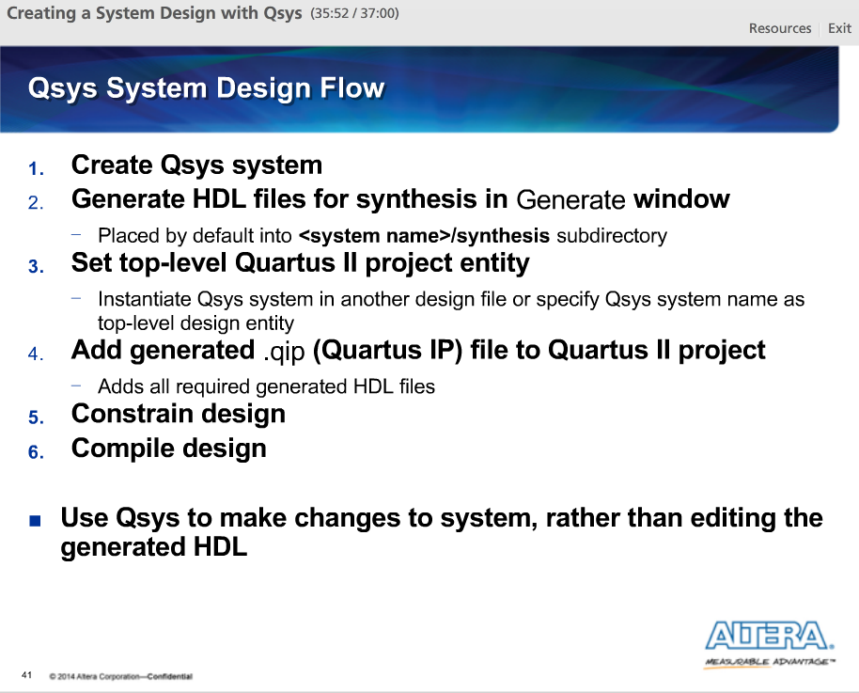

Steps to incorporate Qsys into the typical Quartus II flow.

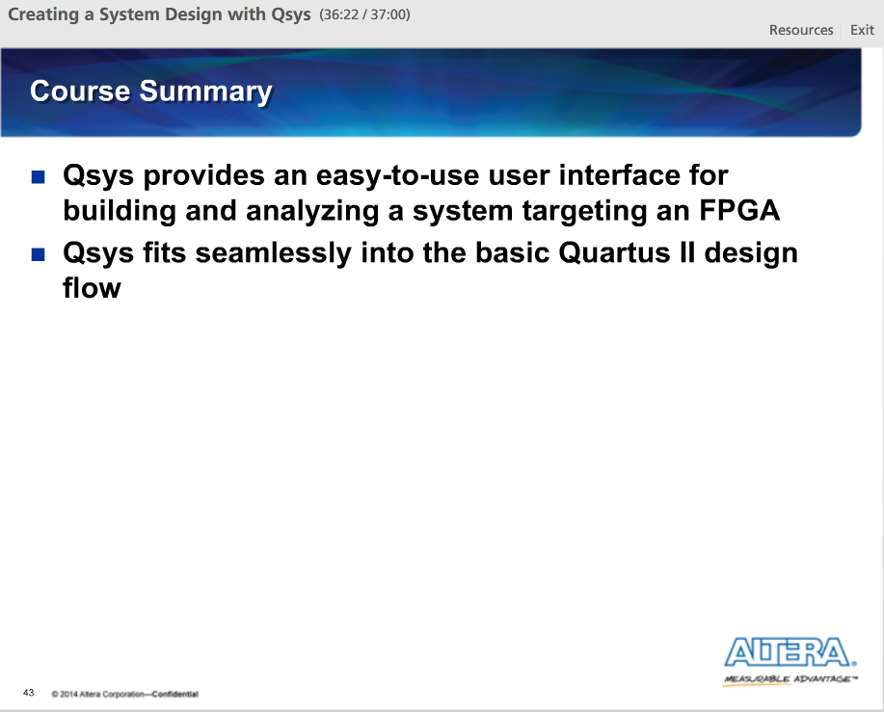

After this lecture, we could see that Qsys provides an easy-to-use UI for constructing designs targeting an Altera FPGA. There are also a variety of tabs and views for analyzing the system for correctness. Once created, Qsys easily fits into the typical Quartus II design flow as another design entry tool.